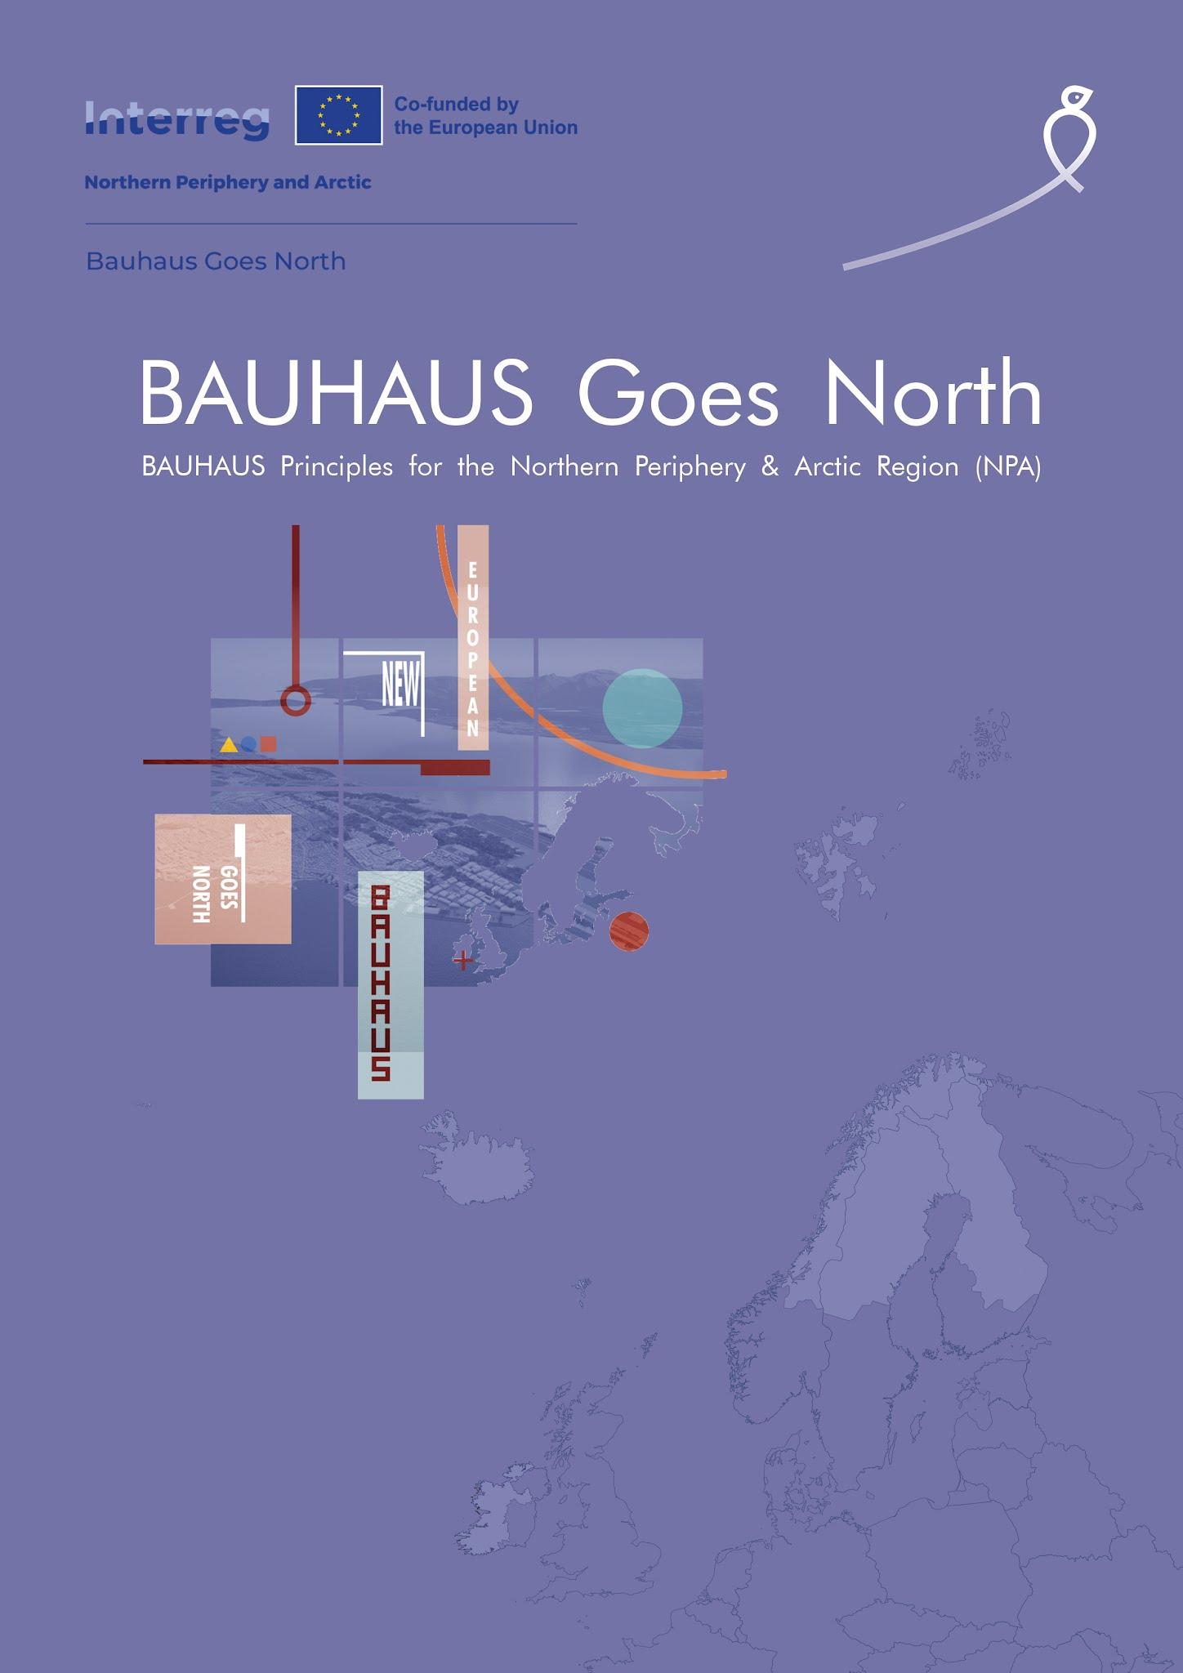
Second Call for Best Practices
in New European Bauhaus in the Northern Periphery and Arctic Region

Application template
EXECUTIVE SUMMARY
Please provide a brief overview of the practice/project, including its objectives, target group, and expected outcomes [1500 characters max].

General information
GENERAL INFORMATION ON THE PRACTICE/PROJECT
Title
Award category | ☐ Circular society  ☐ Circular instruments  ☐ Circular buildings
How many criteria does the project align with? | ☐ One criteria  ☐ Two or three criteria  ☐ All four criteria
Project location
(country, full address)
Project’s development stage | ☐ Developed/implemented  ☐ In the final stage of development/implementation

Project partners
CONTACT PARTNER SUBMITTING THE APPLICATION
Organisation name
Role in the project | ☐ Lead partner  ☐ Partner
Country, full address
VAT/Registration Number
Legal representative
(name and surname)
Contact person
(name and surname)
Email of contact person
Phone of contact person

OTHER PROJECT PARTNERS
Name, address, and role in the project

Alignment with the NEB values
Please provide a brief overview of how the practice/project aligns with the New European Bauhaus (NEB) values [2000 characters max].

Alignment with the NEB working principles
Please provide a brief overview of how the practice/project aligns with the NEB working principles [2000 characters max].

Alignment with the chosen award category
Please provide an overview of how the practice/project aligns with the chosen Call category, considering the criteria within that category [4000 characters max]. More information, including examples for each criterion, can be found in the Guidelines for Applicants here.

Innovative character of the best practice
Please provide an overview of how the practice/project addresses the new obstacles the NPA society faces and how it transforms challenging realities into opportunities. Additionally, explain to what extent the practice creates or utilises innovative technologies, methodologies, and approaches [1000 characters max].

Relevance, transferability and replicability
Please provide an overview of how relevant the practice/project is to the challenges faced by the NPA region, including its adaptability and transferability (within the region and/or to other contexts), and its scalability and replicability on a broader scale [1000 characters max].

Demonstrated results, output, and impact
Please provide a brief overview of the practice/project's demonstrated results, outputs, and impact. In case the project is in its final stage of development/implementation (nearly developed), please describe briefly a plan with the next steps of further development, promotion, or implementation of the practice in the year following the application, demonstrating a commitment to implementing the practice [1000 characters max].



The applications must be submitted under one of the three categories. The same practice (project) cannot be submitted to multiple categories.
Practices/projects aligning with at least two criteria from the chosen category are eligible.
Cooperation among stakeholders from different regions and countries is encouraged. However, the practice (project) must be implemented in the Northern Periphery and Arctic (NPA) region. List of eligible regions and map of the eligible programme area can be found here.
In case VAT is not eligible according to the national legislation, a registration number from the respective national authority (National business registry, Commercial court or similar) must be provided.
Examples of information to include: Sustainability (how the practice/project is sustainable from an environmental perspective): actions related to climate goals, circularity, minimising pollution, or enhancing biodiversity, assessment of the environmental impact of the project, indirect impacts on the environment across time and space. Aesthetics (how the practice/project contributes to increased quality, facilitates style beyond functionality, and integrates heritage with new cultural and social values): creating a positive and enriching experience for people (beyond functionality), reflecting regional or local particularities, utilising local materials and skills, reflecting on future needs of project users, enhancing sensory perceptions. Inclusiveness (how the practice/project contributes to securing equality, accessibility, and affordability for all, e.g., by addressing spatial segregation and isolation, fostering interactions and exchanges between everyone): accessibility and affordability aspects, fostering a sense of community among people with diverse backgrounds and perspectives, promoting new ways of living together, breaking down obsolete and unjust social models.
Examples of information to include: Participatory process (how the practice/project involves various society groups in decision-making and implementation phases, thus empowering local communities): keeping affected groups or communities informed effectively, identifying groups or communities affected by the project thoroughly and reliably, involving affected groups in the project (i.e., in design, decision-making, implementation). Multi-level engagement (how the practice/project works across levels horizontally, e.g., peer, but also vertically, e.g., actors working on different scales – local, regional, national, etc.): cultivating a place-based approach, interacting with informal stakeholders (e.g., local networks and collectives, social representatives), working at different scales or aiming to have an influence across different scales (e.g., local, neighbourhood, city, national). Transdisciplinary approach (how the practice/project integrates results and perspectives of actors from different disciplines): bringing together knowledge from different fields and practitioners from various fields with different educational backgrounds, types/number of various educational backgrounds involved in the project, valuing formal and informal knowledge equally.
Examples of information to include: Circular society: Aspects related to the criteria of (1) resilience, (2) sense of place, (3) high-quality circular design, and (4) participatory and diffuse design. Circular instruments: Aspects related to the criteria of (1) reducing waste, (2) minimize emissions, (3) sustainable mobility, and (4) harnessing digitalization. Circular buildings: Aspects related to the criteria of (1) material circularity, (2) material durability, (3) sustainable energy systems, and (4) reducing fossil fuel dependency.
Practices in the application must either have been fully developed by the time of submission or be at the final stage of development.

