  - STRATEGIC CLARITY

  - A practical advisor handbook for guiding entrepreneurs to clarify strategy, validate assumptions, and execute with focus
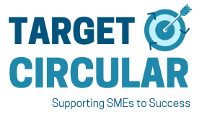
Developed by Dr Niall O’Leary, Head of the Hincks Centre for Entrepreneurship Excellence at Munster Technological University.
Tested and trusted by the partnership of:






Overview
Supporting businesses to succeed is a challenging and complex task, and it is not always obvious how to meet the diverse needs of clients. This handbook translates robust evidence from large-scale studies into a practical, advisor-ready process. The methods provide a structure to guide nearly all clients, regardless of domain, through the difficulties of starting and growing a business. The Target Circular project team of advisors and researchers took these impressive study findings and translated them into this practitioner-ready handbook.
- Proven Approach 1: Milestone Map
In this step you will guide your client to clearly define their goals and work backwards to identify and map essential precursor milestones to achieving those goals. This has many benefits. Firstly, it lays out a path to achieving success with smaller more manageable intermediate milestones. Secondly, the causal relationships between milestones becomes clearer through the visualisation tool which facilitates clients to critically assess and refine their logic. As their often vague ideas crystalise into a concrete vision, you are better able to challenge it, support it, and identify the critical assumptions underlying the venture.
- Proven Approach 2: Structured Validation
Structured validation is testing assumptions identified in the milestone map more systematically than typical and can be thought of as a more rigorous implementation of Lean Start Up. For example, more care is taken selecting the assumption to test and the appropriate method to use (e.g. interviews or pilot). The resulting information gathered is more relevant and reliable providing a far superior foundation to base decisions on.
- Proven Approach 3: Proactive Implementation
The now validated strategy is then translated into a practical plan for day to day and week to week actions towards the venture goal. Emphasizing proactive behaviour, effective habit formation, and resilience, clients learn to align their short-term actions with their long-term strategy.
We call the combined result Strategic Clarity: a shared, explicit understanding of what success looks like, how it will be achieved, and what needs to happen next.
Contents
Overview 2
Introduction 4
STEP 1 The Milestone Map 5
STEP 2 Business Model Canvas 6
STEP 3 Extend your milestone map and identify key assumptions. 6
STEP 4 Structured Validation 7
STEP 5 Personal initiative, proactive and resilient implementation of the validated strategy 8

The digital workspace: This handbook is designed to be used with a digital workspace. The workspace allows advisors and clients to co-create, visualise, develop and access the developed plans over time. This can reduce misunderstandings and increase follow-through. In group contexts – it can also inspire some healthy competition and cross pollination of ideas and strategies. The tools are intentionally lightweight and flexible. Advisors remain free to adapt the process to their context; the workspace simply makes thinking visible and shared. Once familiar with the approach, set up the shared workspace that supports it. If you can facilitate a discussion, you can use this workspace. No advanced technical skills are required, and this short explainer provides the basics you will need https://youtu.be/r0vrPSZjWMQ?si=TZOpUQDO7YHvfzu2.

Template workspace. https://miro.com/app/board/uXjVJ6ohaAA=/?share_link_id=52932939165

Once you have created an account on Miro, click the 3 dots in the top left corner to the left of ‘Strategic Catalyst Template’, click Board, then Duplicate to have an editable version in your own account.
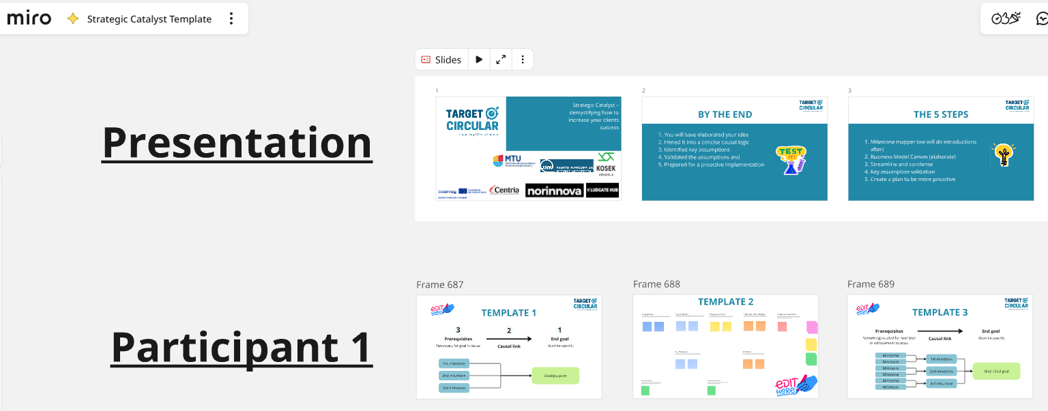
Figure 1. Shared digital workspace used by advisors and participants to visualise strategy, validation activities, and implementation plans.
Printable templates are available upon request.
Contact: Enquiries to Niall.OLeary@mtu.ie.
Acknowledgements: Created as part of the Interreg NPA - funded project Target Circular – Supporting Sustainable SMEs to Success (NPA0100009).

Introduction
The problem: Being a business advisor often involves managing fragmented conversations, repeated firefighting, and clients agreeing to plans but failing to follow through. This common experience is frustrating and partly driven by the fact that entrepreneurs are often overwhelmed by the complexity of creating and running a business and may be aware that the plan doesn’t fully make sense to them yet. Goals, assumptions, and actions remain loosely connected, underlying issues go unaddressed, and the client’s potential for sustained progress and success is constrained.
The solution: This handbook provides a simple and flexible structure to organise thinking and client actions. As client needs evolve through the process, you will take on three distinct roles. For steps 1–2 you will guide clients in making sense of their plan. In steps 3–4, you will become the devil’s advocate challenging their key assumptions. Finally, in step 5, you become a coach supporting execution and implementation of a now elaborated and validated plan.
Opportunity for advisors: When these five steps are used together, advisory work follows a coherent sequence: success is clearly defined, the logic for achieving it is made explicit, critical assumptions are tested before major commitments are made, and execution is translated into concrete routines. Despite strong evidence, these methods are not yet widely used in day-to-day advisory practice. As the basis for a consistent efficient process that will result in more productive session with clients, isolated interventions are transformed into a cumulative process that steadily builds clarity, confidence, and momentum. Leveraging these tools will thus enhance your impact making your clients more competitive and tackling their overwhelm.
Strategic Clarity for clients: Clients will know what they want and what they need to do to get it, be more proactive in executing their strategy, thereby greatly increase their chances of success. With Strategic Clarity – everything becomes easier and success more likely. Large-scale randomised controlled trials across multiple countries show that when entrepreneurs are guided using structured milestone mapping, validation, and implementation routines, outcomes improve significantly, including profitability gains of up to 30% from just one of the methods. The combined effect of these methods in this process may be even greater.

STEP 1 The Milestone Map - Define what success is for the client and how they will achieve it
Defining success is so deceptively simple that advisors and clients often inadvertently overlook it, leaving goals vague and ambiguous. Making the goals and plans specific and unambiguous is thus a basic but powerful step toward success and will be foundational to effectively supporting your clients. In large-scale trials, this approach was shown to significantly improve sales growth. The original research refers to the method as a ‘Story Tree’ emphasising its value to create a narrative; we use the term Milestone Map to emphasise its ability to guide and structure action. The status quo which Milestone Mapping improves upon is that many advisors work to solve clients’ stated short-term problems. Superficially, short-term problem solving is appealing as it is what the client wants in the moment and looks and feels like progress and momentum. It is, however, reacting to clients stated needs when clients, especially at early stages in a venture, typically do not have clarity on their goals and plans.
Begin by clearly defining what success is for clients and how they plan to achieve it. A three-to-five-year timeline is helpful because it obliges clients to go beyond short-term thinking and encourages ambitious goal setting. It is a challenging question for clients to answer on the spot for the first time. They might also feel they should already know the answer to this basic question. If they do not, they may initially deflect and offer vague generic responses like ‘I want the company to succeed’. Your role is to push gently but persistently toward specificity until success is unambiguous. If the client struggles, reassure them that uncertainty at this stage is normal - the map is a thinking aid, not a test and that grappling with these issues now is important for them to be able to succeed. Continue, perhaps at the next session, until success becomes so clear and unambiguous, that you can easily summarise it back to them.
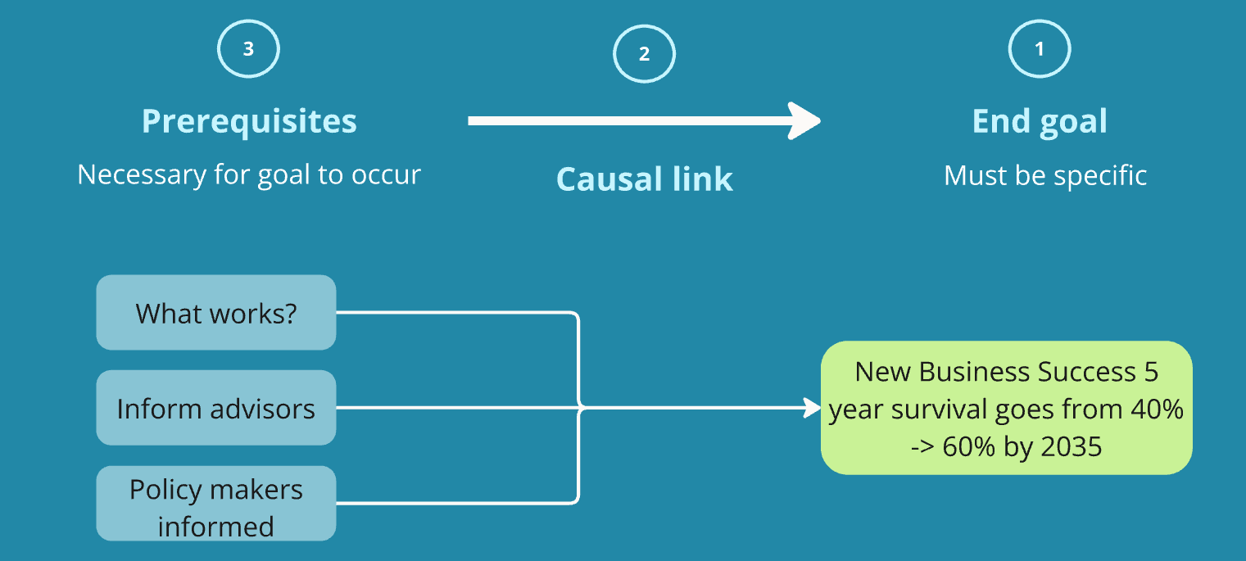
Figure 2 – Simple Milestone Map for increasing entrepreneurial success by promoting the use of evidence based methodologies to advisors.
Now, fill in the milestone map template as you ask or suggest potential precursor milestones to achieving the goal. Working backwards, not forward from today keeps clients from short-term thinking and problem solving prematurely. The direction of arrows represents the direction of causation and carry a lot of meaning – often assumptions that may or may not be true. The visual representation helps you and the client to critically examine assumptions and sense-check the big picture plan. A first map typically takes 15-20 minutes of discussion and reflection. Explainer video. Start With Success: Mapping a Clear Path to Circular Goals

STEP 2 Business Model Canvas
The Milestone Map clarified where the venture is going and what must happen. The Business Model Canvas complements this by systematically examining how the venture is expected to work in practice. It is a structured checklist for gathering key information about a business idea and ensuring common elements to a business plan are thought through. Clients are challenged to examine their ideas from at least nine unique perspectives which allows the concept to be developed step-by-step both visually and conceptually. We limit our focus here on how to use it specifically to strengthen the milestone map and surface critical assumptions as many advisors are already familiar with the Business Model Canvas and guidance on using it is widely available elsewhere. E.g. this video explainer: Business Model Canvas Explained

STEP 3 Extend your milestone map and identify key assumptions.
Informed by the completed business model canvas, extend the milestone map and add more layers of precursors. Like a family tree, success has ‘parent’ precursors, and ‘grandparent’ and even ‘great grandparent’ precursors. These are visualised as working back from the goal. For example, if the goal is X by 2030, Y milestone could be in 2029, and Z could be in 2028. As the map grows, it usually becomes clear that not all milestones matter equally. This is where the advisor’s judgement is critical. Highlight the most important and uncertain aspects of the business model and consider removing unhighlighted boxes. This selection of the most important aspects helps declutter not just the map but also the clients thinking. Furthermore, the interactions between remaining elements will highlight key assumptions. For example, an arrow linking ‘pilot customers secured’ to ‘revenue growth’ assumes customers will repurchase consistently - an assumption that can and should be tested.
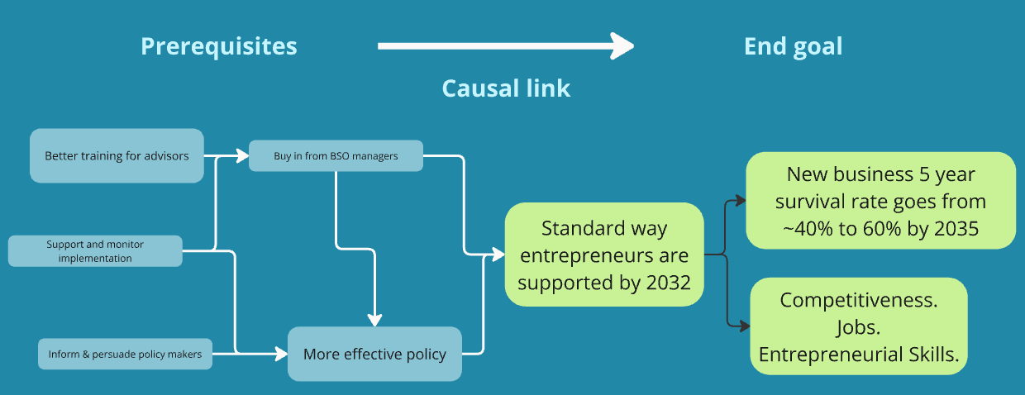
Figure 3. Expanded and streamlined milestone map.
The business model should now be in a form that is simple, concise, and therefore useful that clients can internalize. Internalised means the client can explain the logic of the business clearly, consistently, and without referring to notes. It is internalised in their memory and thinking, informing not just big decisions – but also aligning small, quick, and intuition informed decisions where referring back to formal plans is impractical.
As you discuss with clients work to identify the things that must succeed or be true for the business to succeed. When a causal link is weak (‘this will lead to that’), pause and ask what would have to be true for the arrow to hold. Questionable arrows are assumptions worth testing (step 4). If removing a milestone causes the logic to collapse, you have likely found a key assumption worth validating. Confirm your understanding by asking questions like: ‘Have I understood correctly that X is the end goal, and you will know you have achieved it when Y happens?’, and ‘So if that turns out not to be true, do you think the idea will still work?’.

STEP 4 Structured Validation - Test what really matters before committing time and money
With a clearly elaborated vision in place, the focus now shifts to prioritising and testing the key assumptions. Structured validation enhances this process by: deciding which assumptions matter most, selecting a method to test them, defining in advance how the results will be interpreted, and updating the plan based on what is learned. By generating higher-quality information to inform specific decisions, it makes far better use of clients’ limited time and energy. It does, however, require more upfront investment than typical. The advisor’s role encouraging it is thus valuable. There are five sub-steps to structured validation:
4.1 Prioritise assumptions: It is helpful at the outset to ask what is most important, what is most uncertain and what is most practical to validate. You and your client may need to use judgement regarding which assumptions to prioritise - as it is not always obvious. As a rule of thumb, prioritise assumptions that are both highly uncertain and highly consequential. If the assumption is found to be incorrect, the business model should materially change.
4.2 Define the decision the validation will inform. To inform this judgement, consider how validating the assumption will inform important decisions beforehand. It is helpful at this point outlining ‘if-then’ scenarios – e.g. if the validation finds X, then I will do A, if it finds Y, then I will do B. The desired outcome is not certainty, but sufficient due diligence to give confidence to make the next meaningful decision such as large investments of time or money.
4.3 Choose the lowest-cost method that produces relevant evidence. When selecting a validation method, balance the costs, time, and difficulty against the expected value of the information and aim to select the method that offers the most valuable information relative to the cost. For example, the ease of getting feedback from friends and family might be compared with feedback from potential customers the client has no prior relationship with. Once the method is selected, plan how it will be implemented. Include a timeline, likely obstacles, and how they might be overcome.
4.4 Outline scenarios supporting or contradicting key assumptions: Setting expectations before testing assumptions helps the client better interpret their findings. We are all prone to interpreting evidence in the best light and in ways that protect our ideas. With entrepreneurs, this often extends to protecting against threats to their identity as entrepreneurs. This bias can prevent a client from seeing problems early. They may be tempted to rationalise away bad findings and later realise the truth the hard way after a lot of time and money. This is a tricky situation for an advisor – as clients may not want to face a difficult reality in the moment. It is common for clients to feel discomfort when results challenge their assumptions. Normalising this reaction and anticipating problems beforehand helps cushion the blow and helps maintain trust and keeps the focus on learning rather than justification. They might still ‘move the goalposts’, but this is preferable to placing the goalposts after the validation is performed.
4.5 Update the milestone map based on results. If assumptions have been validated, then the map can usually be streamlined. If found to be incorrect, then the map may need to be revised.
Structured Validation is similar to Lean Start Up but more rigorous than typical Lean Start Up implementations. It improves upon unstructured, trial-and-error or intuition-guided validation approaches which often defaults to the easiest or most obvious option that typically produces weak or misleading information impairing decision making effectiveness. The five step structured validation approach outlined here leads to better decisions including around large investments of time and money, thus saving time and energy in the medium to long term. To support you in this process, a simple template is included in the Miro workspace. Furthermore, this explainer video provides more guidance for how to validate assumptions. Testing What Matters: Validating Key Assumptions

STEP 5 Personal initiative, proactive and resilient implementation of the validated strategy
Steps 1 - 4 clarify what success looks like, how it will be achieved, and which assumptions have been tested. The focus now shifts to implementation: translating a validated strategy into consistent daily and weekly action. This step has the strongest evidence of impact on profitability confirmed by the largest sample size of the 3 studies underpinning this handbook. Again, it may seem basic - but the research shows entrepreneurs benefit dramatically with this guidance and external accountability you can provide. our role thus shifts from planning partner to execution coach, helping to ensure important actions happen consistently and that most actions are aligned with making progress on the Milestone Map.
Coaching clients to develop a more proactive mindset and self starting behaviour is a key aspect here. Success comes from sustained momentum rather than 'Herculean' bursts of energy; by creating prompts and routines, you work with clients to change their default behaviour to that which will propel them towards success, rather than relying on willpower to go against ingrained patterns.
Begin by asking questions like: ‘To achieve this milestone, what does the client need to do daily, weekly and monthly?’, ‘How can clients ensure the most important actions happen?’, and ‘What does the client need to do less of to make time for what really matters?’.
The payoff is that clients are not always deciding what to do on the spot. They should know beforehand what they should be doing and have prompts to ensure critical activities occur.
There are four types of effective behaviours that should be coached:
- Proactive routines and habits. Clients initiate important actions without waiting for ideal conditions, including unglamorous but necessary tasks.
- Learning orientation. Clients regularly seek feedback from customers and stakeholders and adjust behaviour accordingly.
- Future-focused thinking. Clients anticipate upcoming challenges and opportunities rather than reacting only to today’s problems. They are prepared to mitigate potential problems and are ready to capitalize on opportunities when they arise. They are not firefighting with predictable problems or letting opportunities pass due to a lack of awareness or preparation.
- Sustaining momentum. Clients maintain progress over time by balancing persistence with wellbeing, avoiding burnout. The aim is not perfection, but quicker recovery when routines break down.
Example Activities in this Step
- Forward Planning: Set aside time at regular intervals to plan actions that directly move the project towards success. It entails identify what might throw the client off course and developing a plan for how to respond if it occurs beforehand. The following video explains the research behind implementation intentions and provides practical examples. https://youtu.be/DUAB-BW-gZ8?si=F70elPVENiUostXx
- Critical Task Reminders: Identify 2-3 “non-negotiables” that must happen each week (e.g., send outreach emails, review cash flow). Set reminders in your calendar to remind you at the right time.
- Habit Formation Prompts: Tie key activities to existing habits (e.g., "Every morning after coffee, I’ll do 30 minutes of client outreach").

Agarwal, R., Bacco, F., Camuffo, A., Coali, A., Gambardella, A., Msangi, H., Sonka, S., Temu, A., Waized, B., & Wormald, A. (2023). Does a Theory-of-value Add Value? Evidence From a Randomized Control Trial With Tanzanian Entrepreneurs. Organization Science 36(2):601-625. https://doi.org/10.1287/orsc.2023.17590
Camuffo, A., Gambardella, A., Messinese, D., Novelli, E., & Spina, C. (2024). A Scientific Approach to Entrepreneurial Decision Making: Large Scale Replication and Extension. 34(2019), 51–79. http://openaccess.city.ac.uk/1189/
Campos, F., Frese, M., Goldstein, M., Iacovone, L., Johnson, H. C., McKenzie, D., & Mensmann, M. (2017). Teaching personal initiative beats traditional training in boosting small business in West Africa. Science, 357(6357), 1287–1290. https://doi.org/10.1126/science.aan5329

